This is tested in Mac OS Big Sur, and Ubuntu 18.04.

Type the following line on the terminal:

ssh {username}@ottawa.math.carleton.ca -NL 8888:localhost:8888

Put your password. After the password prompt, we notice that the terminal is running, but it doesn’t show anything.

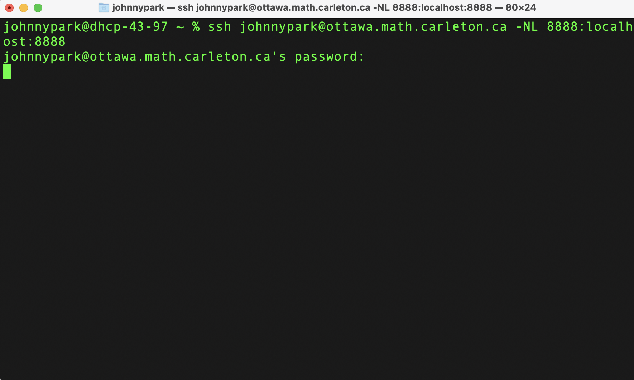

We open another terminal. Type the following in the terminal and log in to the remote PC:

ssh {username}@ottawa.math.carleton.ca

We then enter the password again, to access the remote PC.

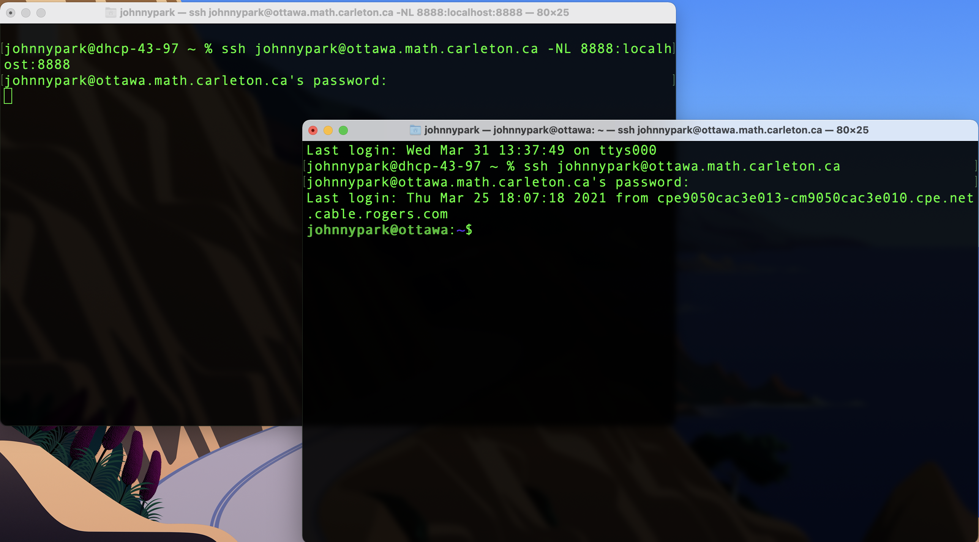

Then we should have juptyer installed in our remote machine. However, we would like to use magma for the notebook, and by default the notebook only supports python kernel. So we would like to separately install the magma kernel in the jupyter notebook.

Run the following command to install:

pip3 install git+https://github.com/nbruin/magma_kernel –user

python3 -m magma_kernel.install

After installation, run the following command in the newly logged in terminal:

jupyter notebook --no-browser --port 8888

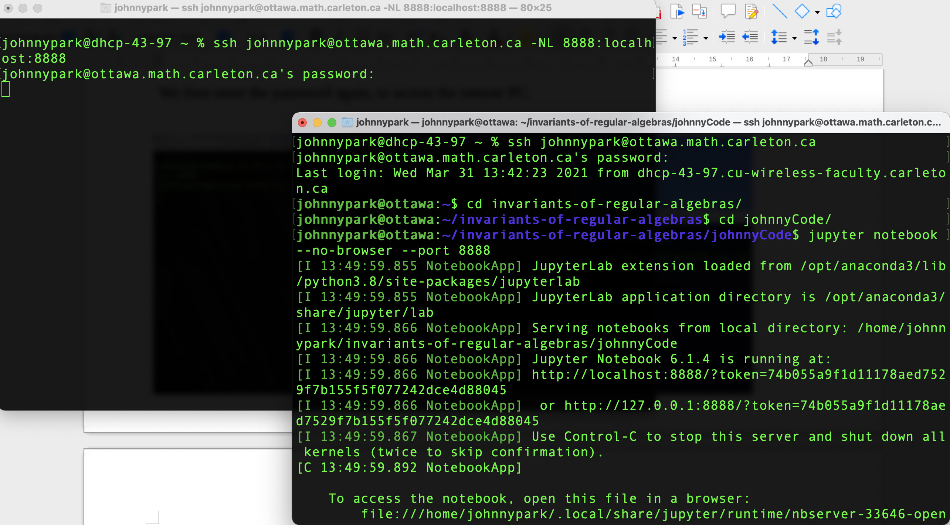

We can then open our browser, and copy the address that the jupyter gives, in my case it is http://localhost:8888/?token=74b055a9f1d11178aed7529f7b155f5f077242dce4d88045

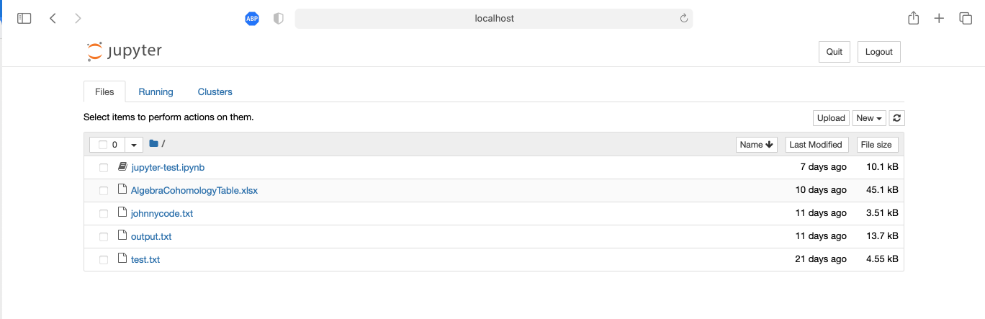

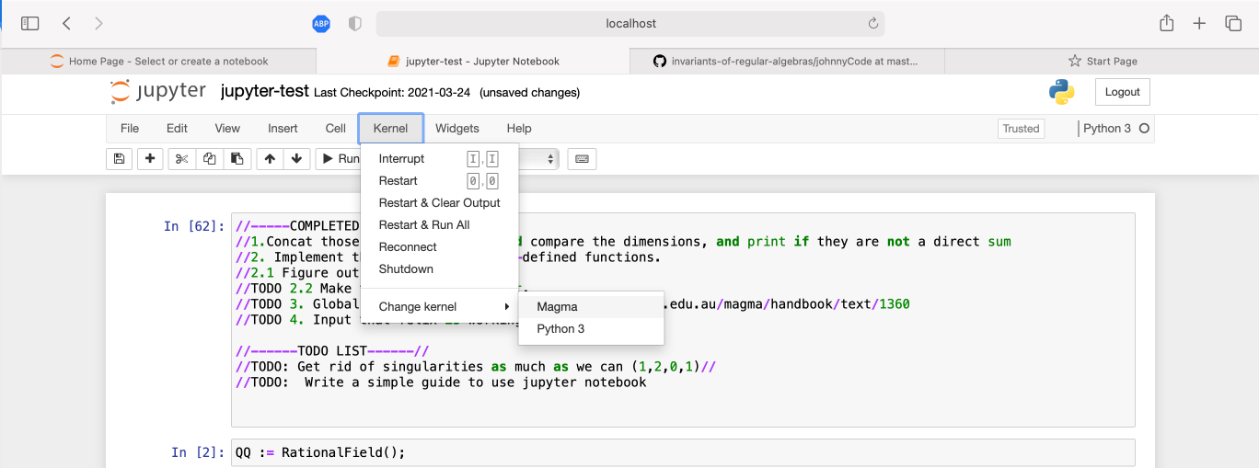

The default kernel is Python 3, so go to Kernel -> Change Kernel -> Magma

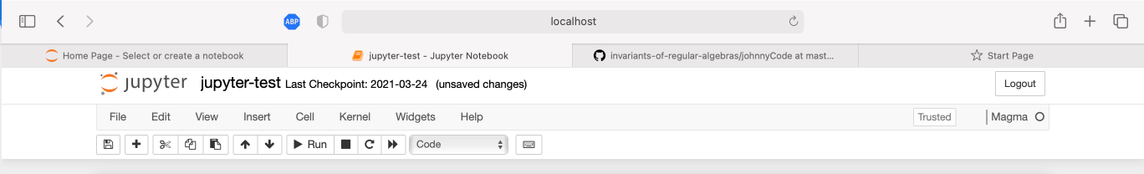

We now have Magma running our local machine in Jupyter notebook.